2.1 Lab – Configuring Basic Switch Settings

Vanisa G. Lungay
IT2-A
02/12/2025

Step 1: Cable the network as shown in the topology.
How many FastEthernet interfaces does a 2960 switch have?
- It has 24 FastEthernet interfaces.
How many Gigabit Ethernet interfaces does a 2960 switch have?
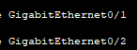
- It has two.

What is the range of values shown for the vty lines?
- The range values shown for vty lines is
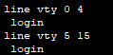

- .Switch# show startup-config
startup-config is not present
Why does this message appear?
- The message appear because there is no saved configuration file in NVRAM of the switch.

- Is there an IP address assigned to VLAN 1?
- No, there is no IP address assigned to VLAN 1. The output of the command “show ip interface vlan1” shows that “internet protocol processing is disabled”, which indicates that no IP address is configured for VLAN.
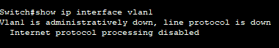

What is the MAC address of this SVI? Answers will vary.
- The MAC address of the SVI is

Is this interface up?
- No, the output shows

- Switch# show ip interface vlan1 What output do you see?
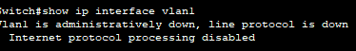
- The output shows

- Examine the Cisco IOS version information of the switch.
Switch# show version
What is the Cisco IOS version that the switch is running?
- The Cisco IOS version that the switch is running is

What is the system image filename?
- The image filename is

What is the base MAC address of this switch? Answers will vary.

- The MAC address of this switch is

- Switch# show interface f0/6
Is the interface up or down?
- The interface is

What event would make an interface go up?

The interface would go up if a device is connected to it with working Ethernet cable and the port is enabled using the command “no shutdown”.

What is the MAC address of the interface?
- The MAC address of the interface is

What is the speed and duplex setting of the interface?
- The speed and duplex setting of the interface is

- Switch# show vlan
What is the default name of VLAN 1?
- Default
Which ports are in this VLAN?
- 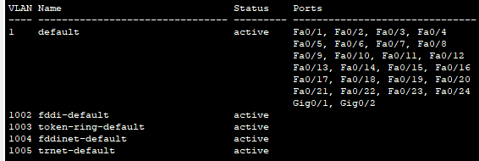

Is VLAN 1 active?
- Yes, VLAN 1 is active.

What type of VLAN is the default VLAN?
- Enet
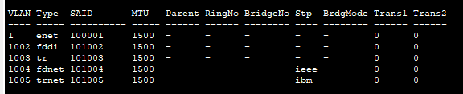

- Examine flash memory.
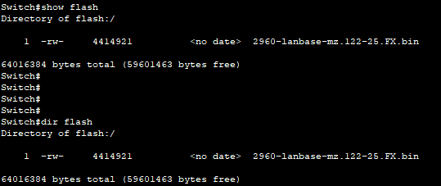
Issue one of the following commands to examine the contents of the flash directory.
Switch# show flash
Switch# dir flash:

Files have a file extension, such as .bin, at the end of the filename. Directories do not have a file extension.

What is the filename of the Cisco IOS image?

Part 2: Configure Basic Network Device Settings

- Assign the switch hostname.
Switch(config)# hostname S1
S1(config)#
- Configure password encryption.
S1(config)# service password-encryption
S1(config)#
- Assign class as the secret password for privileged EXEC mode access.
S1(config)# enable secret class
S1(config)#
- Prevent unwanted DNS lookups.
S1(config)# no ip domain-lookup
S1(config)#
- Configure a MOTD banner.
S1(config)# banner motd #
Enter Text message. End with the character ‘#’.

Unauthorized access is strictly prohibited. #
- Verify your access settings by moving between modes.
S1(config)# exit
S1#
*Mar 1 00:19:19.490: %SYS-5-CONFIG_I: Configured from console by console
S1# exit
S1 con0 is now available

Press RETURN to get started.

Unauthorized access is strictly prohibited. S1>
Which shortcut keys are used to go directly from global configuration mode to privileged EXEC mode?

- Go back to privileged EXEC mode from user EXEC mode. Enter class as the password when prompted.
S1> enable
Password:
S1#
Note: The password does not display when entering.
- Enter global configuration mode to set the SVI IP address of the switch. This allows remote management of the switch.
Before you can manage S1 remotely from PC-A, you must assign the switch an IP address. The default configuration on the switch is to have the management of the switch controlled through VLAN 1.
However, a best practice for basic switch configuration is to change the management VLAN to a VLAN other than VLAN 1.

For management purposes, use VLAN 99. The selection of VLAN 99 is arbitrary and in no way implies that you should always use VLAN 99

Which shortcut keys are used to go directly from global configuration mode to privileged EXEC mode?
- The shortcut key used is “ CTRL-Z”.

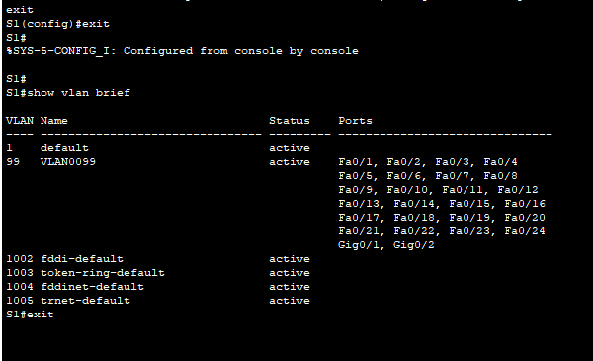
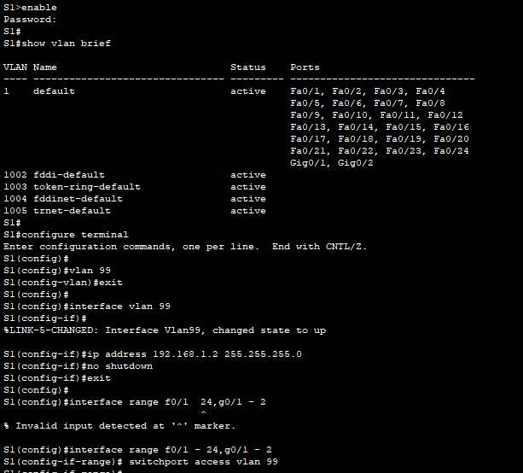
First, create the new VLAN 99 on the switch. Then set the IP address of the switch to 192.168.1.2 with a subnet mask of 255.255.255.0 on the internal virtual interface VLAN 99.
S1# configure terminal S1(config)# vlan 99 S1(config-vlan)# exit S1(config)# interface vlan99
%LINEPROTO-5-UPDOWN: Line protocol on Interface Vlan99, changed state to down
S1(config-if)# ip address 192.168.1.2 255.255.255.0
S1(config-if)# no shutdown S1(config-if)# exit S1(config)#
Notice that the VLAN 99 interface is in the down state even though you entered the no shutdown
command. The interface is currently down because no switch ports are assigned to VLAN 99.
- Assign all user ports to VLAN 99.
S1(config)# interface range f0/1 – 24,g0/1 - 2 S1(config-if-range)# switchport access vlan 99 S1(config-if-range)# exit
S1(config)#
%LINEPROTO-5-UPDOWN: Line protocol on Interface Vlan1, changed state to down
%LINEPROTO-5-UPDOWN: Line protocol on Interface Vlan99, changed state to up
To establish connectivity between the host and the switch, the ports used by the host must be in the same VLAN as the switch. Notice in the above output that the VLAN 1 interface goes down because none
of the ports are assigned to VLAN 1. After a few seconds, VLAN 99 comes up because at least one active port (F0/6 with PC-A attached) is now assigned to VLAN 99.
- Issue show vlan brief command to verify that all the user ports are in VLAN 99.
S1# show vlan brief

VLAN Name Status Ports

1 default active
99 VLAN0099 active Fa0/1, Fa0/2, Fa0/3, Fa0/4 Fa0/5, Fa0/6, Fa0/7, Fa0/8 Fa0/9, Fa0/10, Fa0/11, Fa0/12 Fa0/13, Fa0/14, Fa0/15, Fa0/16 Fa0/17, Fa0/18, Fa0/19, Fa0/20 Fa0/21, Fa0/22, Fa0/23, Fa0/24
Gi0/1, Gi0/2
1002 fddi-default act/unsup
1003 token-ring-default act/unsup
1004 fddinet-default act/unsup
1005 trnet-default act/unsup

- Configure the IP default gateway for S1. If no default gateway is set, the switch cannot be managed from a remote network that is more than one router away. It does respond to pings from a remote network. Although this activity does not include an external IP gateway, assume that you will eventually connect the LAN to a router for external access. Assuming that the LAN interface on the router is 192.168.1.1, set the default gateway for the switch.
S1(config)# ip default-gateway 192.168.1.1
S1(config)#
- Console port access should also be restricted. The default configuration is to allow all console connections with no password needed. To prevent console messages from interrupting commands, use the logging synchronous option.
S1(config)# line con 0 S1(config-line)# password cisco S1(config-line)# login
S1(config-line)# logging synchronous
S1(config-line)# exit
S1(config)#
- Configure the virtual terminal (vty) lines for the switch to allow Telnet access. If you do not configure a vty password, you are unable to telnet to the switch.
S1(config)# line vty 0 15 S1(config-line)# password cisco S1(config-line)# login S1(config-line)# end
S1#
*Mar 1 00:06:11.590: %SYS-5-CONFIG_I: Configured from console by console
Why is the login command required?
- It is required because it enables password checking on a Cisco device. Ensures that only users with the correct credentials can access configuration settings or monitor network traffic.

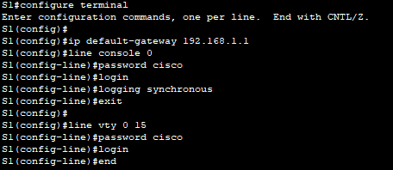

Step 2: Configure an IP address on PC-A.
Assign the IP address and subnet mask to the PC as shown in the Addressing Table. An abbreviated version of the procedure is described here. A default gateway is not required for this topology; however, you can enter 192.168.1.1 to simulate a router attached to S1.
  - Click the Windows Start icon > Control Panel.
  - Click View By: and choose Small icons.

Choose Network and Sharing Center > Change adapter settings.
  - Select Local Area Network Connection, right click and choose Properties.

Choose Internet Protocol Version 4 (TCP/IPv4) > Properties.
  - Click the Use the following IP address radio button and enter the IP address and subnet mask.

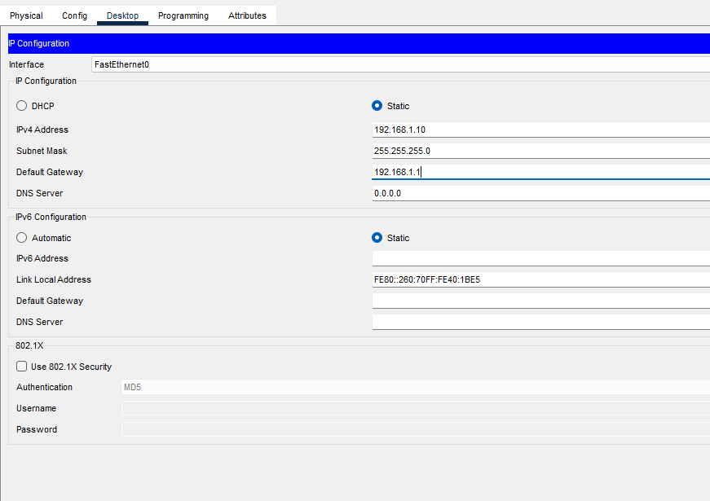

Part 3: Verify and Test Network Connectivity
In Part 3, you will verify and document the switch configuration, test end-to-end connectivity between PC-A and S1, and test the switch’s remote management capability.

Step 1: Display the switch configuration.
From your console connection on PC-A, display and verify your switch configuration. The show run
command displays the entire running configuration, one page at a time. Use the spacebar to advance paging.

- A sample configuration displays here. The settings you configured are highlighted in yellow. The other configuration settings are IOS defaults.
S1# show run
Building configuration...

Current configuration : 2206 bytes
!
version 15.0 no service pad
service timestamps debug datetime msec service timestamps log datetime msec service password-encryption
!
hostname S1
!
boot-start-marker boot-end-marker
!
enable secret 4 06YFDUHH61wAE/kLkDq9BGho1QM5EnRtoyr8cHAUg.2
!
no aaa new-model
system mtu routing 1500
!
!
no ip domain-lookup
!
<output omitted>
!
interface FastEthernet0/24 switchport access vlan 99
!
interface GigabitEthernet0/1
!
interface GigabitEthernet0/2
!
interface Vlan1 no ip address
no ip route-cache
!
interface Vlan99
ip address 192.168.1.2 255.255.255.0
no ip route-cache
!
ip default-gateway 192.168.1.1 ip http server
ip http secure-server
!
banner motd ^C
Unauthorized access is strictly prohibited. ^C

!
line con 0
password 7 104D000A0618 logging synchronous login
line vty 0 4
password 7 14141B180F0B login
line vty 5 15
password 7 14141B180F0B login
!
end

S1#
- Verify the management VLAN 99 settings.

S1# show interface vlan 99
Vlan99 is up, line protocol is up
Hardware is EtherSVI, address is 0cd9.96e2.3d41 (bia 0cd9.96e2.3d41) Internet address is 192.168.1.2/24
MTU 1500 bytes, BW 1000000 Kbit, DLY 10 usec, reliability 255/255, txload 1/255, rxload 1/255
Encapsulation ARPA, loopback not set ARP type: ARPA, ARP Timeout 04:00:00
Last input 00:00:06, output 00:08:45, output hang never Last clearing of "show interface" counters never
Input queue: 0/75/0/0 (size/max/drops/flushes); Total output drops: 0 Queueing strategy: fifo
Output queue: 0/40 (size/max)
5 minute input rate 0 bits/sec, 0 packets/sec
5 minute output rate 0 bits/sec, 0 packets/sec
175 packets input, 22989 bytes, 0 no buffer
Received 0 broadcasts (0 IP multicast)
0 runts, 0 giants, 0 throttles
0 input errors, 0 CRC, 0 frame, 0 overrun, 0 ignored
1 packets output, 64 bytes, 0 underruns
0 output errors, 0 interface resets
0 output buffer failures, 0 output buffers swapped out
What is the bandwidth on this interface?
- The BW on this interface is BW 1000000 Kbit
What is the VLAN 99 state?
- The VLAN 99 state is up.
What is the line protocol state?
- The line protocol state is up.

Step 2: Test end-to-end connectivity with ping.
- From the command prompt on PC-A, ping your own PC-A address first.
C:\Users\User1> ping 192.168.1.10

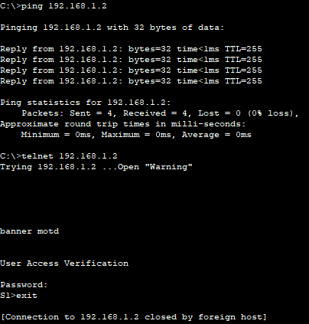

- From the command prompt on PC-A, ping the SVI management address of S1.
C:\Users\User1> ping 192.168.1.2
Because PC-A needs to resolve the MAC address of S1 through ARP, the first packet may time out. If ping results continue to be unsuccessful, troubleshoot the basic device configurations. You should check both the physical cabling and logical addressing if necessary.

Step 3: Test and verify remote management of S1.
You will now use Telnet to remotely access the switch. In this lab, PC-A and S1 reside side by side. In a production network, the switch could be in a wiring closet on the top floor while your management PC is located on the ground floor. In this step, you will use Telnet to remotely access switch S1 using its SVI management address. Telnet is not a secure protocol; however, you will use it to test remote access. With Telnet, all information, including passwords and commands, are sent across the session in plain text. In subsequent labs, you will use SSH to remotely access network devices.
Note: If you are using Windows 7, the administrator may need to enable the Telnet protocol. To install the Telnet client, open a cmd window and type pkgmgr /iu:“TelnetClient”. An example is shown below.
C:\Users\User1> pkgmgr /iu:”TelnetClient”
- With the cmd window still open on PC-A, issue a Telnet command to connect to S1 via the SVI management address. The password is cisco.
C:\Users\User1> telnet 192.168.1.2
- After entering the password cisco, you will be at the user EXEC mode prompt. Access privileged EXEC mode.
- Type exit to end the Telnet session.

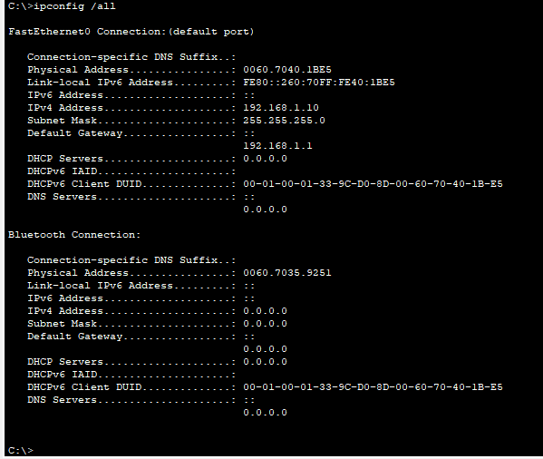

Step 4: Save the switch running configuration file.
Save the configuration.
S1# copy running-config startup-config Destination filename [startup-config]? [Enter] Building configuration...
[OK]
S1#

Part 4: Manage the MAC Address Table
In Part 4, you will determine the MAC address that the switch has learned, set up a static MAC address on one interface of the switch, and then remove the static MAC address from that interface.

Step 1: Record the MAC address of the host.
From a command prompt on PC-A, issue ipconfig /all command to determine and record the Layer 2 (physical) addresses of the PC NIC.

Step 2: Determine the MAC addresses that the switch has learned.
Display the MAC addresses using the show mac address-table command.

S1# show mac address-table
How many dynamic addresses are there?

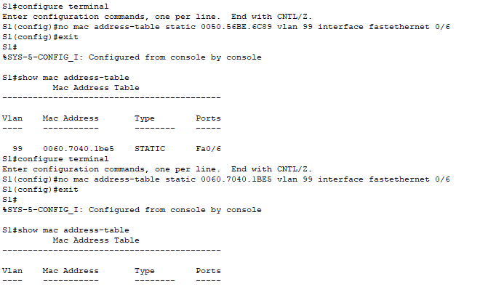
- There is none.

How many MAC addresses are there in total?
- 1 mac address.
Does the dynamic MAC address match the PC-A MAC address?
- The MAC address shown is only static.

Step 3: List the show mac address-table options.
- Display the MAC address table options.

S1# show mac address-table ?
How many options are available for the show mac address-table command?
- There are 3.
- Issue the show mac address-table dynamic command to display only the MAC addresses that were learned dynamically.

S1# show mac address-table dynamic
How many dynamic addresses are there?
- The output does not show dynamic address.
- View the MAC address entry for PC-A. The MAC address formatting for the command is xxxx.xxxx.xxxx.
S1# show mac address-table address <PC-A MAC here>

Step 4: Set up a static MAC address.
- Clear the MAC address table.
To remove the existing MAC addresses, use the clear mac address-table command from privileged EXEC mode.

S1# clear mac address-table dynamic
- Verify that the MAC address table was cleared.

S1# show mac address-table
How many static MAC addresses are there?
- None.
How many dynamic addresses are there?
- None
- Examine the MAC table again.
More than likely, an application running on your PC has already sent a frame out the NIC to S1. Look at the MAC address table again in privileged EXEC mode to see if S1 has relearned the MAC address for PC-A.

S1# show mac address-table

How many dynamic addresses are there? None.
Why did this change from the last display?
- This changed from the last display after pinging. PC-A sent a frame to the switch as part of the ping (ICMP Echo Request) process.

If S1 has not yet relearned the MAC address for PC-A, ping the VLAN 99 IP address of the switch from PC-A, and then repeat the show mac address-table command.
- Set up a static MAC address.
To specify which ports a host can connect to, one option is to create a static mapping of the host MAC address to a port.
Set up a static MAC address on F0/6 using the address that was recorded for PC-A in Part 4, Step 1. The MAC address 0050.56BE.6C89 is used as an example only. You must use the MAC address of your PC- A, which is different than the one given here as an example.

S1(config)# mac address-table static 0060.7040.1BE5 vlan 99 interface fastethernet 0/6

- Verify the MAC address table entries.

S1# show mac address-table
How many total MAC addresses are there?
- There are 1.
How many static addresses are there?
- There are 1 static address.
- Remove the static MAC entry. Enter global configuration mode and remove the command by putting a no
in front of the command string.
Note: The MAC address 0050.56BE.6C89 is used in the example only. Use the MAC address for your PC-A.

S1(config)# no mac address-table static 0060.7040.1BE5 vlan 99 interface fastethernet 0/6
- Verify that the static MAC address has been cleared.

S1# show mac address-table
How many total static MAC addresses are there? -None

Reflection
- Why should you configure the vty lines for the switch?
- To improve the security and management capabilities of the switch, allowing for better remote administration and preventing unauthorized access.

- Why change the default VLAN 1 to a different VLAN number?
- VLAN 1 is the default VLAN for management and control traffic. Changing to a different VLAN number helps separate management traffic from regular network traffic, reducing the risk of unauthorized access.

- How can you prevent passwords from being sent in plain text?
- Use the service password-encryption command to encrypt passwords in the configuration file and use SSH instead of telnet.

- Why configure a static MAC address on a port interface?
- This prevents things like MAC address spoofing and ensures traffic only goes to the correct port.

Appendix A: Initializing and Reloading a Router and Switch

Step 1: Initialize and reload the router.
  - Console into the router and enable privileged EXEC mode.
Router> enable
Router#
  - Enter the erase startup-config command to remove the startup configuration from NVRAM.
Router# erase startup-config
Erasing the nvram filesystem will remove all configuration files! Continue? [confirm] [OK]
Erase of nvram: complete Router#
  - Issue the reload command to remove an old configuration from memory. When prompted to Proceed with reload?, press Enter. (Pressing any other key aborts the reload.)
Router# reload
Proceed with reload? [confirm]
*Nov 29 18:28:09.923: %SYS-5-RELOAD: Reload requested by console. Reload Reason: Reload Command.

Note: You may receive a prompt asking to save the running configuration prior to reloading the router. Respond by typing no and press Enter.
System configuration has been modified. Save? [yes/no]: no
  - After the router reloads, you are prompted to enter the initial configuration dialog. Enter no and press Enter.
Would you like to enter the initial configuration dialog? [yes/no]: no
  - Another prompt asks to terminate autoinstall. Respond by typing yes press Enter.
Would you like to terminate autoinstall? [yes]: yes

Step 2: Initialize and reload the switch.
- Console into the switch and enter privileged EXEC mode.
Switch> enable
Switch#
- Use the show flash command to determine if any VLANs have been created on the switch.
Switch# show flash
Directory of flash:/

2 | -rwx | 1919 | Mar | 1 | 1993 | 00:06:33 | +00:00 | private-config.text
3 | -rwx | 1632 | Mar | 1 | 1993 | 00:06:33 | +00:00 | config.text
4 | -rwx | 13336 | Mar | 1 | 1993 | 00:06:33 | +00:00 | multiple-fs
5 | -rwx | 11607161 | Mar | 1 | 1993 | 02:37:06 | +00:00 | c2960-lanbasek9-mz.150-2.SE.bin
6 | -rwx | 616 | Mar | 1 | 1993 | 00:07:13 | +00:00 | vlan.dat

32514048 bytes total (20886528 bytes free) Switch#
- If the vlan.dat file was found in flash, then delete this file.
Switch# delete vlan.dat
Delete filename [vlan.dat]?
- You are prompted to verify the filename. If you have entered the name correctly, press Enter; otherwise, you can change the filename.
- You are prompted to confirm to delete this file. Press Enter to confirm.
Delete flash:/vlan.dat? [confirm] Switch#
- Use the erase startup-config command to erase the startup configuration file from NVRAM. You are prompted to remove the configuration file. Press Enter to confirm.
Switch# erase startup-config
Erasing the nvram filesystem will remove all configuration files! Continue? [confirm] [OK]
Erase of nvram: complete Switch#
- Reload the switch to remove any old configuration information from memory. You will then receive a prompt to confirm to reload the switch. Press Enter to proceed.
Switch# reload
Proceed with reload? [confirm]

Note: You may receive a prompt to save the running configuration prior to reloading the switch. Respond by typing no and press Enter.
System configuration has been modified. Save? [yes/no]: no
- After the switch reloads, you should see a prompt to enter the initial configuration dialog. Respond by entering no at the prompt and press Enter.
Would you like to enter the initial configuration dialog? [yes/no]: no
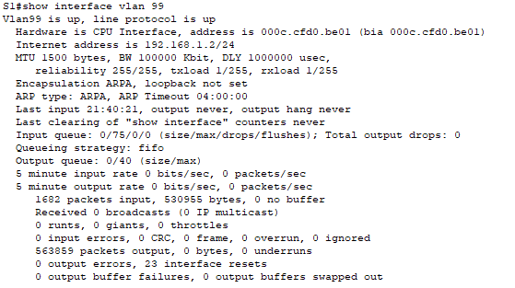
Switch>

